KIRIKKALE ÜNİVERSİTESİ
SAĞLIK BİLİMLERİ ENSTİTÜSÜ

ONLİNE KAYIT KILAVUZU

ONLİNE KAYIT İŞLEMLERİNİZİ AŞAĞIDA BELİRTİLEN ADIMLARI TAKİP EDEREK YAPABİLİRSİNİZ.

1.ADIM___________________________________


2. ADIM__________________________________
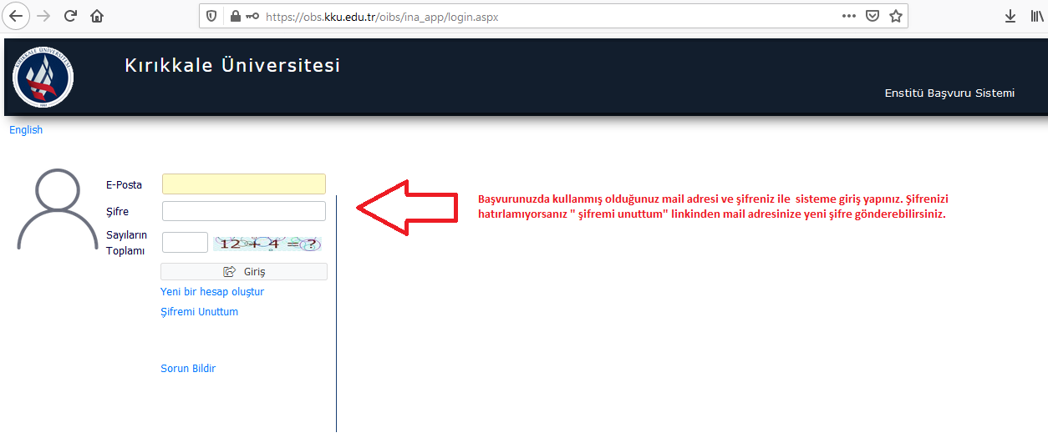

3.ADIM___________________________________
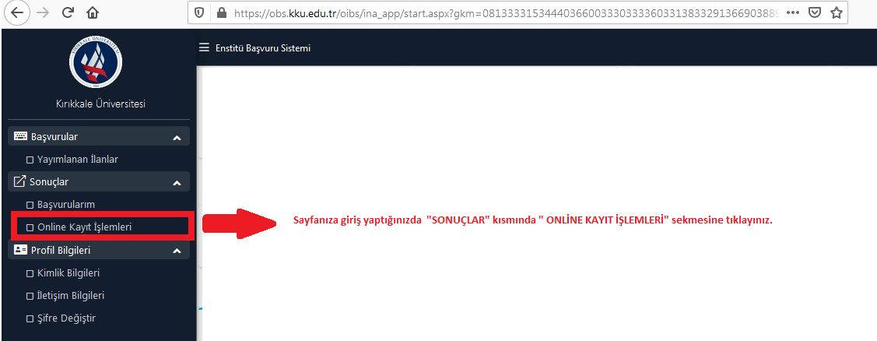
4. ADIM__________________________________
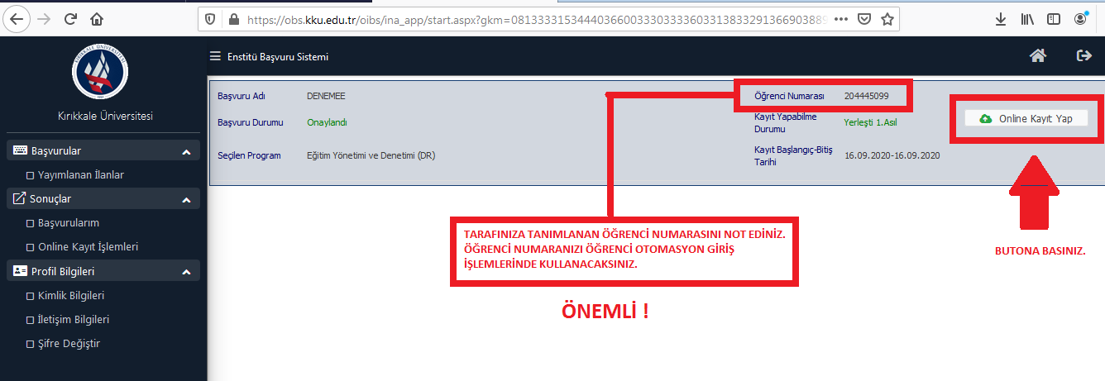

5. ADIM__________________________________
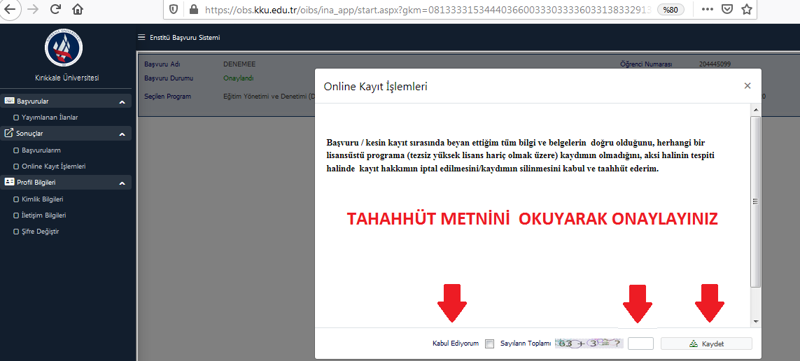

6.ADIM___________________________________
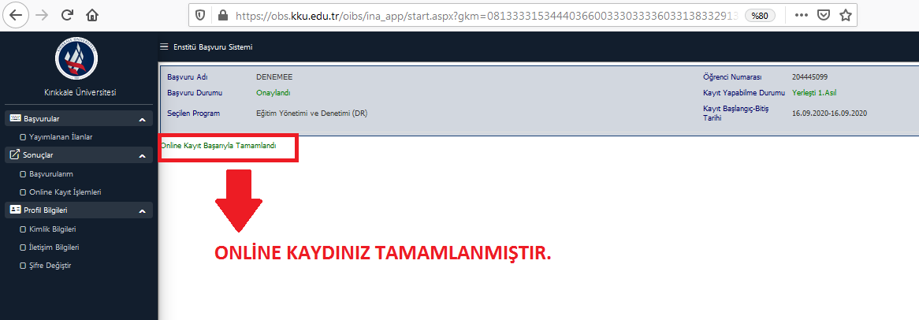

7.ADIM___________________________________
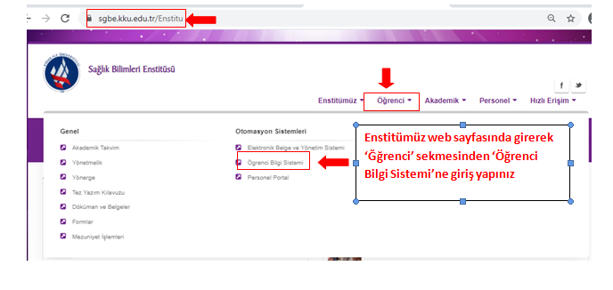
8.ADIM___________________________________
